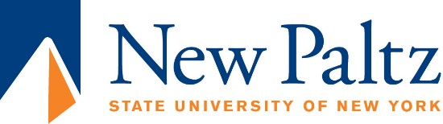
Office of Compliance & Campus Climate

Affirmative Action/Equal Employment Opportunity Statement

All qualified applicants will receive consideration for employment without regard to age, race, color, religion, sex, national origin, disability, gender, gender identity of protected veteran status. Candidates who bring diverse cultural experience and who are especially qualified to mentor and advise all members of our diverse student population are especially encouraged to apply. The State University of New York at New Paltz is an AA/EOE/ADA employer.

