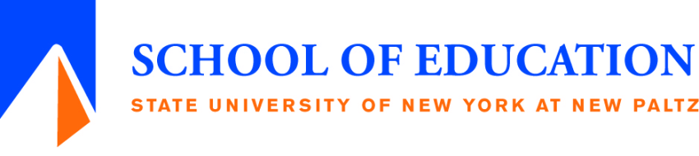
Fall 2018 Teacher Certification Workshop
Registration Form

These mandated trainings are ONLY for MATRICULATED SUNY New Paltz Students who will be seeking teacher certification.
Please select workshops:
____SAVE on 11/3 in Lecture Center 108 from 9:30 to 12:00
____Child Abuse on 11/3 in Lecture Center 108 from 1:00 to 3:30
____DASA on 10/13 in Old Main B125 from 9:00 to 4:00
--OR--
____DASA on 11/10 in Lecture Center 108 from 9:00 to 4:00

Registration Deadlines:
DASA 1: Wednesday, Oct. 10th, SAVE/CA: Wednesday Oct. 31st, or DASA 2: Wednesday, Nov. 7th

Name:_____________________________________ Email ______________________________
Student Number: N_____________________
Address:_______________________________________________________________________
Phone where we will most likely reach you: ________________________________
______Undergraduate student ______Graduate student
Check your area of specialization:
____Art Education ____Secondary Education
____Educational Administration ____Speech & Language Disabilities
____Elementary Education ____TESOL
____Literacy ____Other _________________
____School Counseling
FEES: $15 for SAVE; $15 for Child Abuse; $20 for DASA by Money Orders Only—No other form of payment is accepted. (Money orders may be purchased at U.S. post offices, most banks, convenience stores, check-cashing services, and many grocery store customer service desks. Please make them out to: “SUNY New Paltz, Acct. # 900039.”)
Drop off Registration Forms along with Money Orders to: Gina Rondon in Old Main, Room 218C,
(Mondays 2:00 to 6:00; Wednesdays 4:00 to 6:00; Fridays 2:00 to 6:00)

You will receive a confirmation.

Online Option:

The upside of taking SAVE and Child Abuse ID workshops on-campus is that they are more interactive, better quality, and have no graded quizzes. Also, proof of completion will be automatically documented on students' transcripts and sent to the Teach Account once the workshop is completed.

If you cannot take the workshops on campus, there are online workshops available at the following sites. (There is no online version of DASA.) These are not affiliated with New Paltz, so you will need to register directly for them. If you use the code below, you will receive a reduced rate.

www.childabuseworkshop.com
www.violenceworkshop.com

Registration code: NewPaltz9
(Code works for New Paltz students only; your certificate will say “SUNY New Paltz”)
Fee: $15 per course
Log in with the code and pay on-line with a credit card to begin the training.

- This on-line option is available 24 hours/day, you may log out and back in as often as needed. Help is available.

- Courses are timed to make sure that students spend time on each chapter and ensure compliance with State regulations.

- Upon completion, you must send your certificate of completion yourself and submit it to Records & Registration, HAB 19, Attn: Rita Cancelliere
or email it to recreg@newpaltz.edu

